CHAPTER NO | LIST OF CONTENTS | PAGE NO
1 | INTRODUCTION | 1
 | 1.1 Project Overview
 | 1.2 Purpose
2 | IDEATION PHASE
 | 2.1 Problem Statement
 | 2.2 Empathy Map Canvas
 | 2.3 Brainstorming
3 | REQUIREMENT ANALYSIS
 | 3.1 Customer Journey map
 | 3.2 Solution Requirement
 | 3.3 Data Flow Diagram
 | 3.4 Technology Stack
4 | PROJECT DESIGN
 | 4.1 Problem Solution Fit
 | 4.2 Proposed Solution
 | 4.3 Solution Architecture
5 | PROJECT PLANNING & SCHEDULING
 | 5.1 Project Planning
6 | FUNCTIONAL AND PERFORMANCE TESTING
 | 6.1 Functional And Non Functional
 | 6.2 Performance Testing
7 | RESULTS
 | 7.1 Output Screenshots
8 | ADVANTAGES & DISADVANTAGES
9 | CONCLUSION
10 | FUTURE SCOPE
11 | APPENDIX

Introduction
In the retail industry, effective product placement and pricing strategies play a crucial role in influencing customer purchasing behavior and overall sales performance. With the increasing availability of data, businesses can leverage analytical tools to understand how various factors such as product category, store placement, promotions, seasonality, consumer demographics, and foot traffic impact sales volume and pricing. This project utilizes Tableau to perform an in-depth visual analysis of these factors, enabling data-driven insights that support better merchandising and marketing decisions.
The study focuses on exploring patterns and relationships between different retail variables and their effect on average sales volume. By visualizing the data through interactive dashboards and stories, the project aims to simplify complex datasets into meaningful insights that can be easily interpreted and used for decision-making.

1.1 Project Overview
The Product Placement Analysis project is designed to evaluate how different retail strategies and environmental factors influence sales performance across various product categories. The analysis is carried out using Tableau by creating an interactive dashboard and a sequential story that collectively present key insights derived from the dataset.
The dashboard integrates multiple visualizations such as bar charts, donut charts, heatmaps, pie charts, and bubble charts to compare sales volume, pricing, promotions, and demographic contributions. It provides a comprehensive view of how clothing, electronics, and food categories perform under different placement positions like aisle, front-of-store, and end-cap. Additionally, the dashboard highlights the role of promotional activities, seasonal demand, and varying levels of foot traffic in shaping sales outcomes.
The story component further breaks down the analysis into individual insights, guiding the viewer through a structured explanation of how each factor contributes to product performance. This combination of dashboard and story enhances the clarity and effectiveness of the analytical findings.

1.2 Purpose of the Project
The primary purpose of this project is to analyze and understand the impact of product placement and related retail factors on average sales volume and pricing. By examining different variables such as promotions, seasonality, consumer demographics, and foot traffic, the project aims to identify which strategies are most effective in improving product visibility and sales performance.
Another key objective is to demonstrate how data visualization tools like Tableau can be used to transform raw retail data into actionable insights. The project helps in identifying optimal product placement positions, understanding customer segment contributions, and evaluating the effectiveness of promotional campaigns.
Overall, the purpose of this project is to support better retail decision-making by providing clear, data-driven insights that help businesses optimize store layout, pricing strategies, and marketing efforts to maximize sales and customer engagement.

2. Ideation Phase

2.1 Problem Statement
PS–1: Retail & Consumer Goods Perspective
I am a retail business manager trying to understand how product positioning within stores and digital platforms impacts sales performance and customer purchasing behavior. However, I lack clear and visual insights into which product placements drive higher visibility and conversions. This is because sales data, placement details, and customer demographics are scattered and difficult to interpret together. As a result, I feel uncertain about how to optimize product placement strategies to increase revenue and customer engagement.
PS–2: Film & Television Production Companies
I am a film or television production executive trying to evaluate the effectiveness of product placements within scenes and episodes. However, I cannot clearly measure audience engagement or the revenue impact of different placement strategies. This is because there is no visual and data-driven approach to analyze placement performance across content and brands. This makes me feel challenged when negotiating brand partnerships and planning future placement opportunities.
PS–3: Advertising Agencies
I am an advertising agency strategist trying to demonstrate the ROI of product placement campaigns across various media channels. However, I struggle to present clear insights on which placements perform best. This is because campaign data is complex and lacks intuitive visualization. Due to this, I feel limited in optimizing campaigns and delivering strong, data-backed recommendations to clients.

2.2 Empathy Map Canvas
The empathy map represents the mindset of a retail decision-maker who uses Tableau dashboards to analyze product positioning and sales performance.
Thinks:
The decision-maker thinks that product placement directly influences sales visibility and customer engagement. They believe that visual dashboards should provide clear comparisons across product categories, positions, and demographics. They also consider competitor pricing and seasonal trends while evaluating placement strategies. Additionally, they expect data visualization tools to combine multiple metrics like promotions, foot traffic, and pricing into a single analytical view.
Feels:
The decision-maker feels pressured to improve sales performance and stay competitive in a dynamic retail environment. They feel confident when dashboards provide accurate and real-time insights but also anxious when placement decisions are based on incomplete or scattered data. They are motivated to find data-driven solutions that enhance product visibility and customer experience, yet sometimes feel overwhelmed by large volumes of unstructured retail data.
Says:
The decision-maker often says that clear visual dashboards help in comparing category performance effectively. They emphasize the need to understand how different placements such as aisle, end-cap, and front-of-store influence sales. They also mention that promotional strategies and seasonal trends should be analyzed together to make better merchandising decisions.
Does:
The decision-maker reviews Tableau dashboards regularly to monitor sales trends by product category and placement position. They compare performance across consumer demographics, promotional campaigns, and foot traffic levels. Based on insights, they adjust product placement strategies, collaborate with marketing teams, and test different positioning approaches to maximize sales and customer engagement.
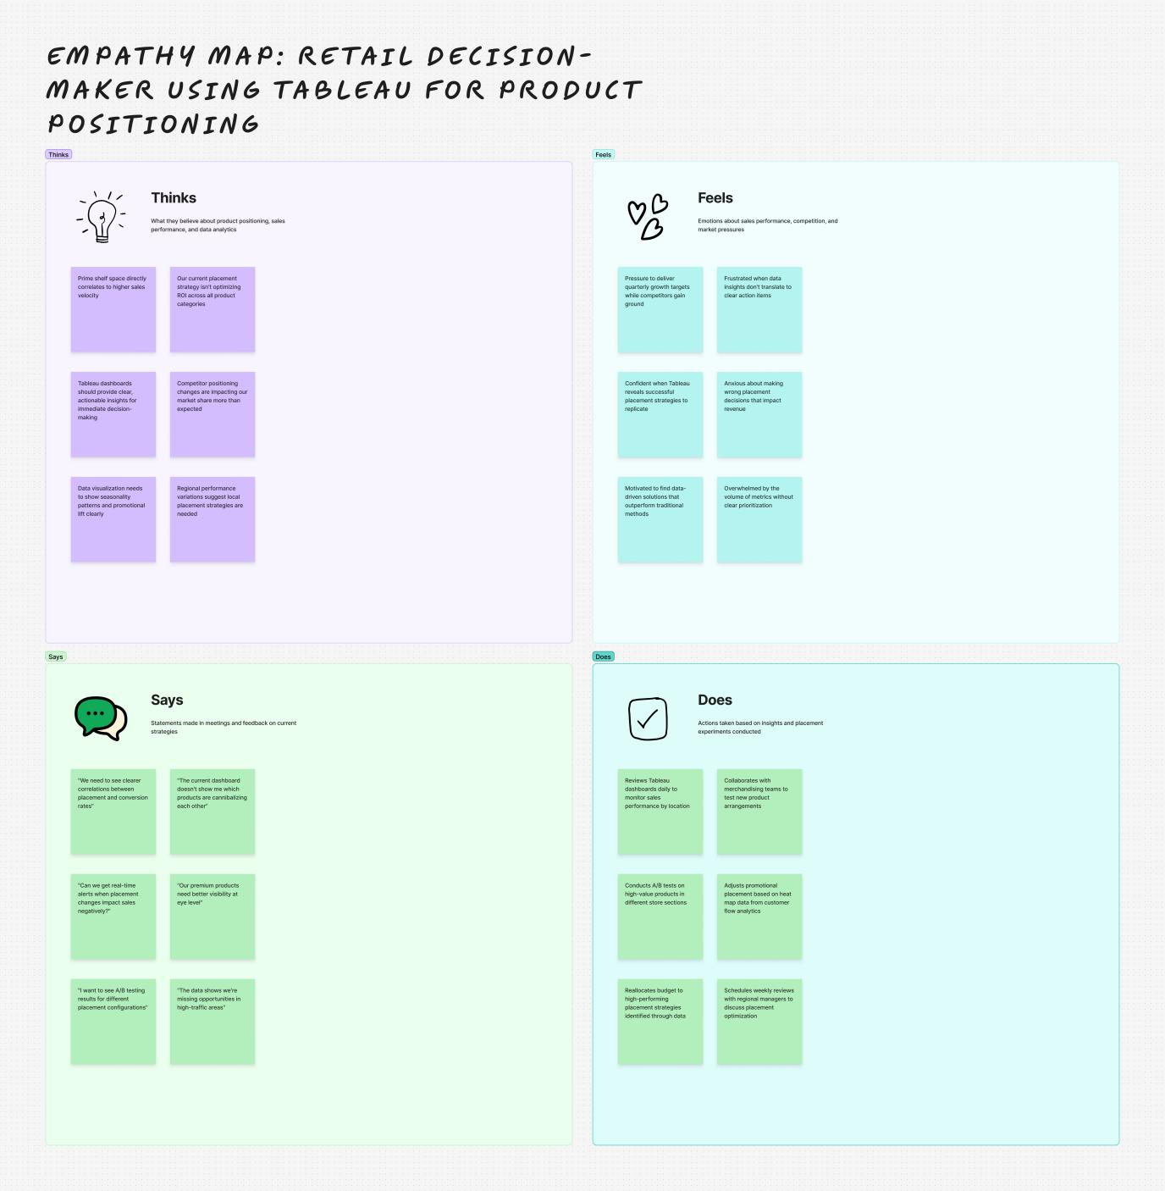

2.3 Brainstorming
During the brainstorming phase, multiple ideas were generated to explore how product placement analysis can be enhanced using data visualization and analytics.
From a data analysis perspective, ideas included correlating sales data with product placement locations such as aisle, end-cap, and front-of-store. Time-series analysis was considered to evaluate how placement changes affect sales trends over different seasons. Segmenting data by product category and price point was also proposed to identify high-performing segments.
From a visualization and dashboard perspective, the team proposed building interactive Tableau dashboards that display placement effectiveness through heatmaps, bar charts, and bubble charts. Designing before-and-after comparison dashboards for A/B testing and creating real-time performance trackers were also key brainstorming outcomes.
From a consumer behavior perspective, ideas focused on linking customer demographics such as age groups and families to placement preferences. Analyzing dwell time, impulse buying patterns, and customer journey touchpoints near specific product positions were also discussed to understand how visibility influences purchasing decisions.
From a business and marketing impact perspective, brainstorming emphasized calculating ROI for different placement strategies, optimizing shelf-space allocation, and benchmarking performance against competitor strategies. Additional ideas included designing targeted marketing campaigns based on placement insights and building executive summary dashboards for strategic decision-making.
These brainstorming activities helped in identifying high-impact analytical features and guided the development of the final Tableau dashboard and story for effective product placement analysis.
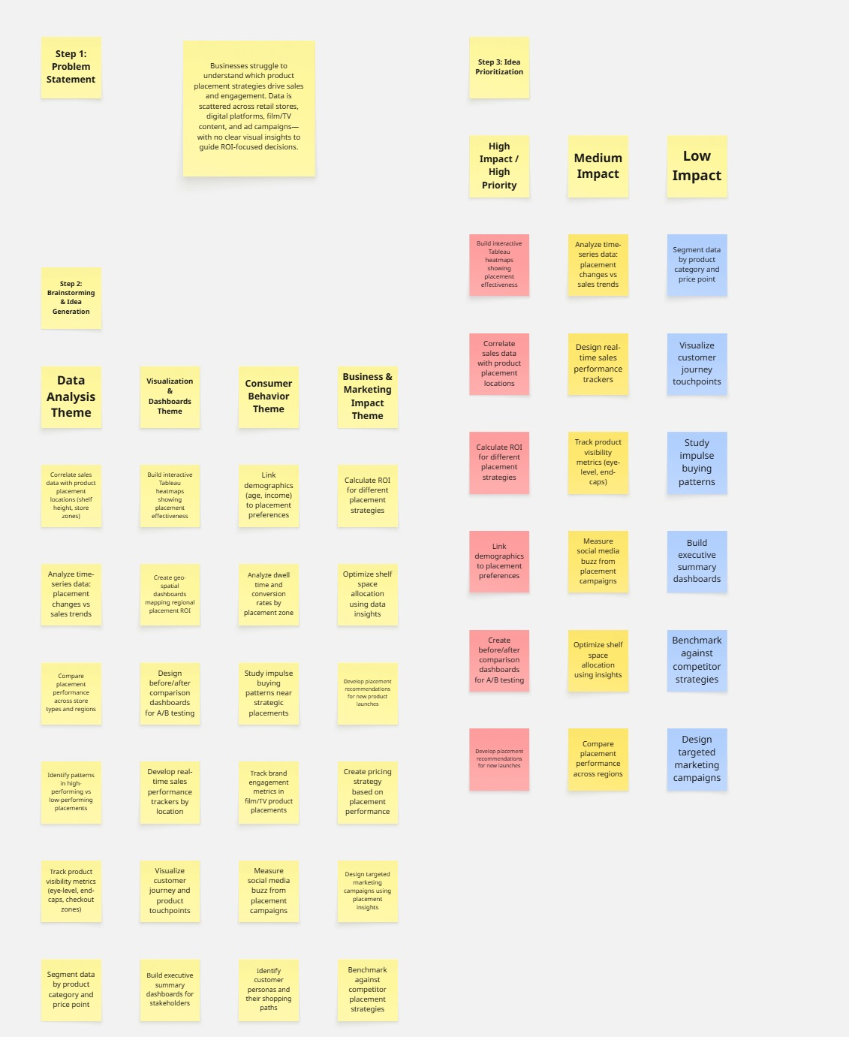

3. Requirement Analysis

3.1 Customer Journey Map
Stage | Customer Actions | Touchpoints | Pain Points | Opportunities
Awareness | Notices product placement in store or online | Store shelves, end-caps, homepage banners | Poor visibility, cluttered layout | Optimize shelf position & digital placement
Consideration | Compares products based on placement, price, promotions | In-store aisles, product pages | Hard to identify highlighted products | Use strategic positioning & visual cues
Decision | Chooses product influenced by visibility and promotions | Checkout counter, featured sections | Confusion due to scattered info | Clear placement with data-backed arrangement
Purchase | Completes purchase after exposure to well-placed products | POS systems, online cart | Missed impulse buying opportunities | Data-driven placement to boost conversions
Post-Purchase | Shares feedback and repeat purchase behavior | Feedback forms, loyalty programs | No tracking of placement effectiveness | Use analytics dashboards for insights

3.2 Solution Requirements

Functional Requirements
- Collect sales transaction data from retail systems.
- Gather product placement details (aisle, shelf, front-store, digital position).
- Integrate consumer demographic and behavior data.
- Clean and transform raw data for analysis.
- Analyze correlation between placement and sales performance.
- Provide interactive dashboards to visualize placement effectiveness.
- Generate reports with insights and recommendations.
- Enable filtering by category, demographics, time, and promotion campaigns.

Non-Functional Requirements
- High data accuracy and reliability
- Real-time or near real-time dashboard updates
- User-friendly and interactive visualization interface
- Secure data storage and role-based access
- Scalable architecture to handle large retail datasets
- Fast processing for quick business decisions

3.3 Data Flow Diagram (DFD)

Level 0 – Context Flow
The system collects data from:
- Sales Systems (sales transactions)
- Consumer Analytics Platforms (demographic data)
The system processes and transforms the data to produce:
- Interactive dashboards
- Visualization reports
- Strategic insights for business decision makers

Level 1 – Detailed Flow
- Data Collection:
Raw sales data and consumer demographic data are gathered.
- Data Repositories:
Sales Data Repository.
Product Placement Database.
Consumer Demographics Database.
- Data Cleaning & Transformation:
Raw data is cleaned, structured, and standardized.
- Product Placement Analysis:
Analytical models evaluate how placement impacts sales and engagement.
- Data Visualization:
Processed insights are converted into dashboards and visual reports.
- Insights & Recommendations:
Reports provide actionable strategies for optimizing product placement.
- Business Decision Makers:
Use insights to adjust marketing and placement strategies.

3.4 Technology Stack Used
The following technologies were used to develop the Product Placement Analysis Dashboard:
1. Data Source
- CSV / Excel datasets containing sales, product category, promotions, pricing, and foot traffic details.
2. Data Preparation & Processing
- Tableau Data Source Panel – for importing and cleaning the dataset
- Built-in Tableau data cleaning options (handling nulls, data types, sorting, grouping)
3. Data Analysis
- Tableau Calculated Fields – used to compute:
- Average Price
- Average Sales Volume
- Category-wise comparisons
- Promotion impact analysis
4. Data Visualization
- Tableau Desktop – to create interactive dashboards and charts such as:
- Bar charts
- Comparison visuals
- Category-wise performance graphs
- Promotion vs Non-promotion analysis visuals
5. Dashboard & Story Design
- Tableau Dashboard – for combining multiple visualizations
- Tableau Story – to present insights in a step-by-step narrative format
6. Filters & Interactivity
- Tableau Filters – applied on:
- Product Category
- Promotion (Yes/No)
- Store Zones / Foot Traffic Levels
7. Platform / Environment
- Windows Operating System
- Tableau Desktop Public Edition (for development and visualization)

4. Project Design

4.1 Problem–Solution Fit
The analysis of the problem–solution fit indicates that retail and marketing stakeholders face challenges in understanding how product placement, promotions, and pricing influence sales performance. Existing approaches rely heavily on manual Excel reports, basic dashboards, and intuition-based decision-making, which often lead to delayed insights and ineffective placement strategies. Additionally, fragmented data sources and the lack of integrated analytical tools prevent businesses from correlating product positioning with consumer purchasing behavior.
To address these gaps, the proposed dashboard-driven analytical system aligns with the identified customer needs. The solution integrates sales data, product placement information, and consumer demographic insights into a unified visualization platform. This enables stakeholders such as business analysts, marketing managers, and retail decision-makers to identify high-performing placement strategies, measure ROI on promotions, and make data-driven decisions. Thus, the designed system directly fits the problem context by transforming raw data into actionable insights through interactive visual analytics.

4.2 Proposed Solution
The proposed solution is an interactive Product Placement Analysis Dashboard developed using Tableau. The system consolidates multiple datasets related to sales transactions, product categories, promotion status, pricing, and foot traffic into a centralized analytical environment. The dashboard allows users to visually explore how different placement strategies (Aisle, End-cap, Front of Store) and promotional activities affect average sales volume and pricing trends.
The solution provides dynamic filters, calculated metrics, and comparative visualizations to support effective analysis. Users can evaluate performance across product categories such as Clothing, Electronics, and Food, and compare promotional versus non-promotional sales outcomes. By presenting key performance indicators and trend comparisons in a user-friendly interface, the proposed solution enhances decision-making efficiency, reduces manual analysis effort, and improves the accuracy of marketing and placement strategies.

4.3 Solution Architecture
The solution architecture follows a structured data analytics pipeline that transforms raw business data into meaningful insights through visualization and reporting.
- Decision Support Layer:
The final insights and recommendations derived from the dashboard assist business decision-makers and marketing teams in optimizing product placement strategies, improving promotional effectiveness, and enhancing overall revenue performance.
- Data Collection Layer:
Sales transaction data, product placement details, and consumer demographic information are collected from various retail data sources and stored in structured datasets.
- Data Repository Layer:
The collected data is organized into separate repositories such as Sales Data Repository, Product Placement Database, and Consumer Demographics Data. This ensures systematic storage and easy accessibility for further processing.
- Data Preprocessing & Transformation Layer:
The raw datasets undergo cleaning, validation, and transformation processes. Missing values are handled, data types are standardized, and calculated fields such as Average Price and Average Sales Volume are derived to support analytical requirements.
- Analytical Processing Layer:
The processed data is analyzed to identify relationships between product placement strategies, promotional campaigns, and sales performance. This layer generates insights on high-performing placements and customer behavior trends.
- Visualization & Reporting Layer:
Interactive dashboards and stories are developed in Tableau to represent analytical findings through charts, graphs, and KPI indicators. These visual reports allow users to explore insights dynamically using filters and parameters.
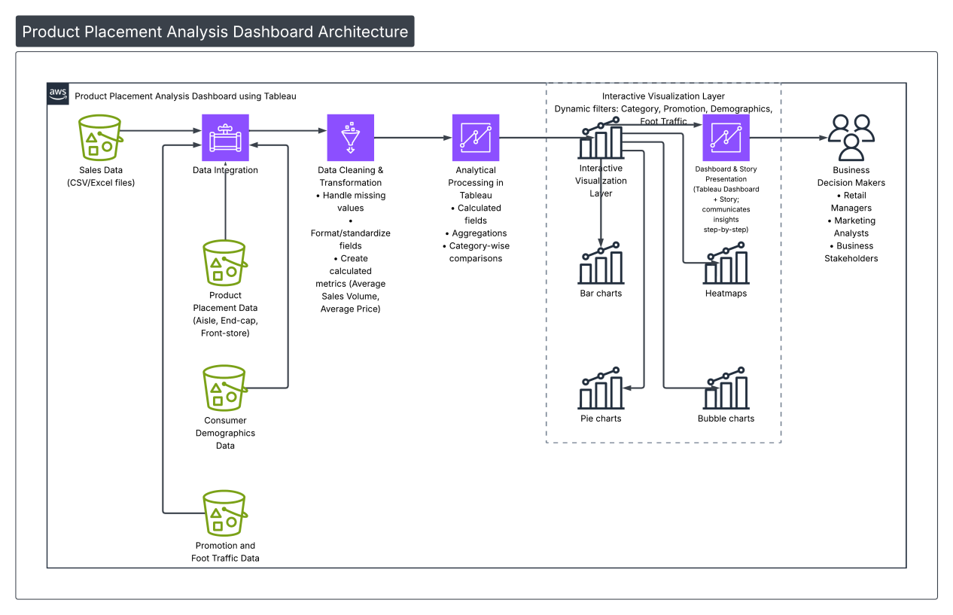
This architecture ensures a smooth flow from raw data acquisition to strategic decision-making, thereby providing a scalable and efficient analytical solution for product placement performance evaluation.

5.1 Project Planning
The project planning phase outlines the systematic approach followed to design and develop the Product Placement Analysis Dashboard. The planning ensured that each stage of the project was executed in an organized manner, from data understanding to final dashboard deployment.
Initially, the project objectives were clearly defined to analyze how product placement, pricing, promotions, and consumer demographics influence sales performance. Based on these objectives, the required datasets were identified, including sales data, product category details, promotional information, and customer demographic data.
In the next stage, a detailed plan was prepared for data preparation and analysis. This involved data collection, cleaning, preprocessing, and transformation to ensure accuracy and consistency. After preprocessing, the analytical requirements were mapped to suitable visualizations such as bar charts, pie charts, heat maps, and bubble charts to effectively represent the insights.
Following the analysis phase, the dashboard design was planned with a focus on usability and clarity. The layout was structured to include key visualizations like average sales by category, consumer demographics vs sales, competitor price comparison, heatmap of product positions, and seasonal sales analysis. Interactive filters were planned to allow users to dynamically explore data based on product category, placement position, promotion status, and consumer segments.
Finally, a story was planned to present the analytical flow in a logical sequence, enabling stakeholders to easily understand the insights and recommendations. The project planning ensured timely completion, proper organization of tasks, and effective utilization of Tableau features to achieve the desired analytical outcomes.

6.1 Functional and Performance Testing

6.1.1 Functional Testing
Functional testing was carried out to ensure that all components of the Product Placement Analysis Dashboard work correctly according to the specified requirements. Each visualization, filter, and calculated field was tested to verify accurate data representation and interactivity.
All charts such as average sales by product category, consumer demographics vs sales volume, competitor price comparison, and heatmap of product placement were validated with the dataset to confirm that the displayed values match the underlying data. Filters for product category, promotion status, and consumer demographics were tested to ensure they dynamically update all relevant visualizations without errors.
Calculated fields used for average price, average sales volume, and category-wise comparisons were also checked for correctness. Additionally, dashboard navigation and story flow were tested to ensure smooth transitions between different analytical views. The functional testing confirmed that the dashboard provides correct insights, interactive filtering, and accurate aggregation of data.

6.1.2 Performance Testing
Performance testing was conducted to evaluate the responsiveness and efficiency of the dashboard when handling the dataset. The loading time of visualizations, filter response time, and interaction speed were monitored during testing.
The dashboard was tested with multiple filters applied simultaneously to ensure that it responds quickly without lag. It was observed that the dashboard efficiently loads visual elements and updates visualizations in real time when filters are selected. Aggregations and calculations were optimized using Tableau’s in-built processing, which improved performance and reduced computation time.
Overall, the dashboard demonstrated stable performance, fast rendering of charts, and smooth interactivity, making it suitable for real-time analysis and decision-making.

RESULT

Dashboard :

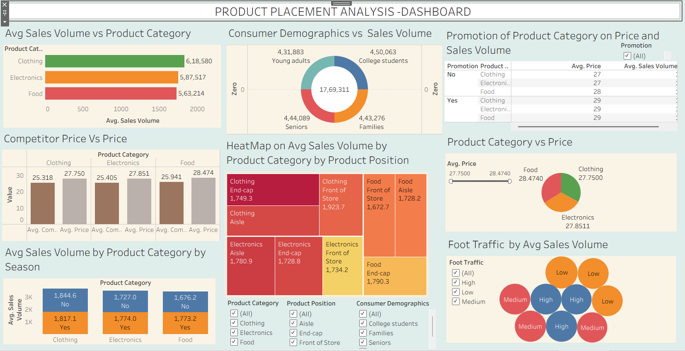

Story:

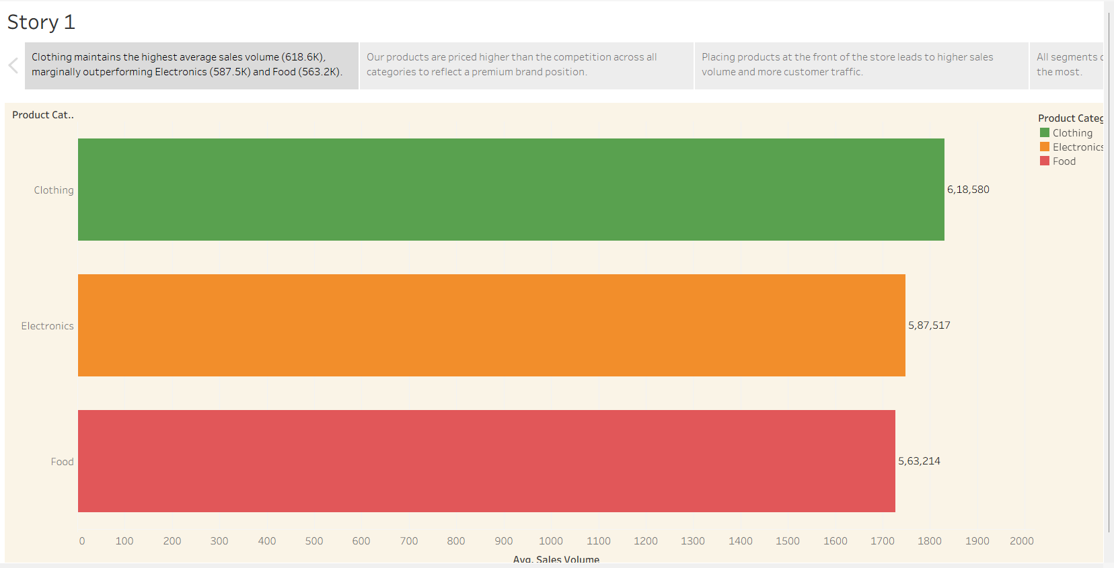

8. Advantages and Disadvantages

8.1 Advantages
- Provides clear insights into how product placement impacts sales performance.
- Interactive dashboard allows users to filter data by category, promotion, and demographics.
- Helps in identifying high-performing product positions such as end-cap and front-of-store.
- Integrates multiple factors like pricing, promotions, and consumer demographics in one platform.
- Supports data-driven decision-making for marketing and merchandising strategies.
- Easy visualization of trends through charts, heatmaps, and comparison graphs.

8.2 Disadvantages
- Analysis depends on the quality and completeness of the input dataset.
- Limited to historical data; cannot fully predict future sales trends.
- Dashboard performance may reduce with extremely large datasets.
- Does not include real-time data integration from live retail systems.
- External factors such as market competition and seasonal demand variations are not deeply modeled.

9. Conclusion
The Product Placement Analysis Dashboard successfully demonstrates how data visualization can be used to evaluate the effectiveness of product placement strategies. By analyzing sales volume, pricing, promotions, consumer demographics, and store positions, the project provides meaningful insights into factors influencing product performance. The interactive Tableau dashboard enables users to explore data dynamically and make informed business decisions. Overall, the project highlights the importance of strategic product placement and data-driven analytics in improving sales and optimizing retail strategies.

10. Future Scope
- Integration with real-time retail and sales databases for live analysis.
- Implementation of predictive analytics to forecast future sales trends.
- Inclusion of additional factors such as seasonal trends, competitor campaigns, and customer feedback.
- Deployment of the dashboard on cloud platforms for wider accessibility.
- Enhancement with advanced machine learning models to recommend optimal product placement strategies automatically.

11. Appendix
Dataset Link:
Please use the link to download the dataset:
https://www.kaggle.com/datasets/amitvkulkarni/impact-of-product-positioning-on-sales

Youtube Link :

https://www.youtube.com/watch?v=ZmgbcdDENAw

Github link:

https://github.com/grandiradhika/Strategic-Product-Placement-Analysis

